- From the Access Gateway Administration Tool, select the Access Gateway Cluster tab and then open the window for the Access Gateway.
- Under the Certificate Signing Request tab, supply the following information:
· Country, State and City name.
· Company name and Department.
· The FQDN through which your server is accessed externally.
· Email address.
· A password for the private key.
· A key length of 2048.
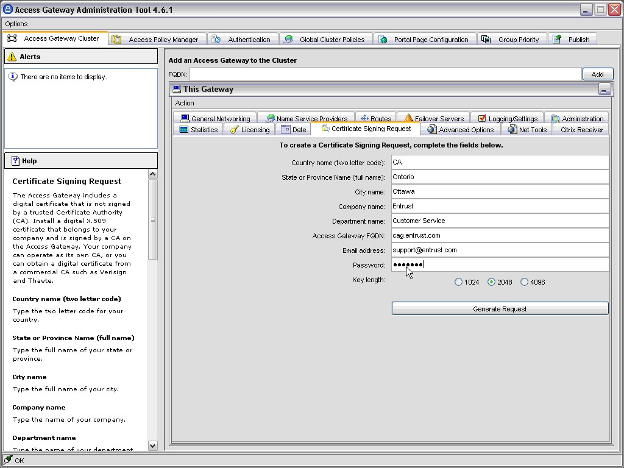
- Click Generate Request.
- Supply a file name to save your Certificate Signing Request (CSR) and click Save.
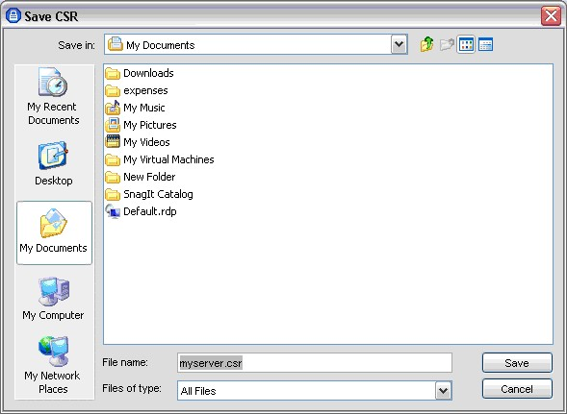
- You should see a dialog box indicating that the CSR was generated successfully.
