To generate the CSR, complete the following steps:  
  
** Note these steps are based on NSv9.1

Part 1 - Create a Private Key

From the NetScaler GUI, select **NetScaler > SSL > Create RSA Key.**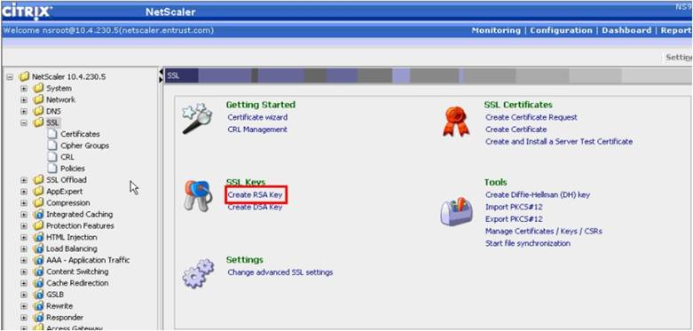

1. Supply a private key name for your certificate. Choose a key size of 2048. Keep the default values for the remaining options and click **Create**.  
     
   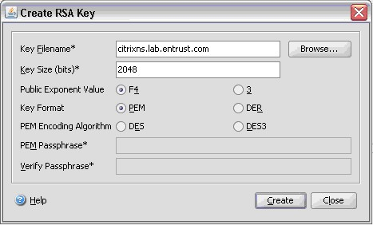
2. Click **Close** to close the Create RSA Key window.

Part 2 - Create a Certificate Signing Request

1. From the NetScaler GUI, select **NetScaler > SSL > Create Certificate Request**.  
   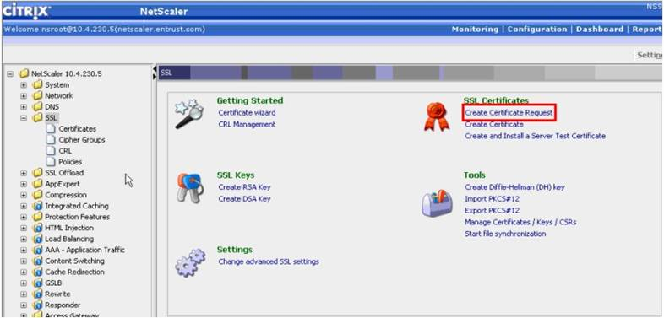
2. In the Create Certificate Request window, supply the following information:  
     
   ·         A Request File Name for the certificate.  
   ·         The Key File Name. This should match the private key name created in Step 2 above.  
   ·         Distinguished Name Fields information.  
     
   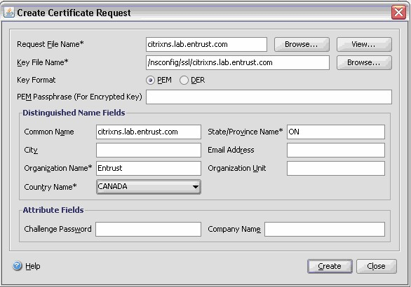
3. Click **Create** to create the certificate request file.
4. Click **Close** to close the Create Certificate Request window.