- Click on the Start menu, go to All Programs, then Microsoft Exchange Server 2007 and click onExchange Management Shell.
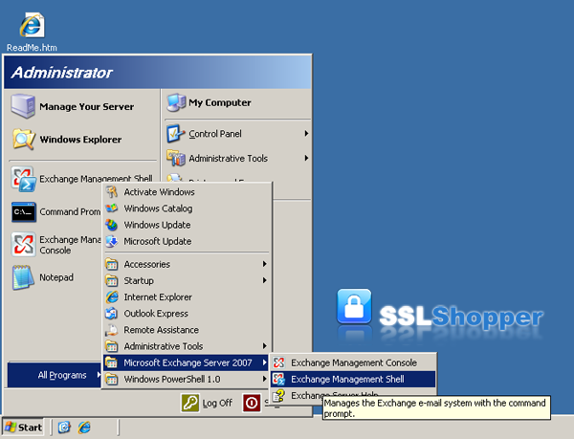
- Run the New-ExchangeCertificate command below replacing the appropriate values with your own.
- New-ExchangeCertificate -domainname mail.google.com, google.com, google.local, autodiscover.google.com, server01.google.com, server01 -Friendlyname google.com -generaterequest:$true -keysize 2048 -path c:\certrequest.txt -privatekeyexportable:$true -subjectname "c=US, o=Google Inc., cn=server01.google.com, s=California, l=Mountain View, ou=IT"
Name | Explanation | Examples
-domainname | Enter all of the names that you determined you needed to secure in the step above. | mail.google.com  autodiscover.google.com  google.com  google.local  Server01.google.local  Server01
-Friendlyname | Any name you want to use to keep track of the certificate on this server. | my google certificate
-keysize | The size of the key that is generated. Bigger numbers are more secure but can be slower. Use at least 1024. | 1024  2048
-path | The location where you want to save the CSR. | c:\certrequest.txt
Common Name (cn=) | Enter the first name in your list above. This is the most visible name in the certificate (the other names are listed as Subject Alternative Names and they aren't displayed as clearly) | mail.yourdomain.com
Organization (o=) | The legal name of your organization. This should not be abbreviated and should include suffixes such as Inc, Corp, or LLC. Do not include commas or the command won't work. | Google Inc.
Organizational Unit (ou=) | The division of your organization handling the certificate. | Information Technology  Web
City/Locality (l=) | The city where your organization is located. | Mountain View
State/province (s=) | The state/region where your organization is located. This shouldn't be abbreviated. | California
Country/Region (c=) | The two-letter ISO code for the country where your organization is location. | US  GB
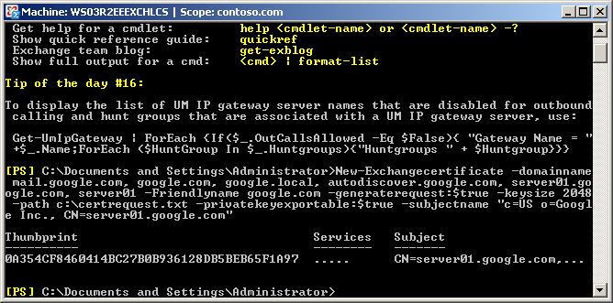
Once you have generated a CSR you can use it to order the certificate from a certificate authority.

