To install your newly acquired SSL certificate in Exchange 2007, first copy the certificate file somewhere on the server and then follow these instructions:
- Click on the Start menu, go to All Programs, then Microsoft Exchange Server 2007 and click onExchange Management Shell.
- Run the Import-ExchangeCertificate command below. Make sure to specify the path to the certificate file you downloaded and remove any services that you will not be using.
Import-ExchangeCertificate -path c:\google.cer | Enable-ExchangeCertificate -Services IMAP, POP, UM, IIS, SMTP

- If you didn't receive any errors, then it should have installed correctly. Run the Get-ExchangeCertificate command to verify that the certificate is enabled for the correct services. If you aren't sure which thumprint it is, you can view the thumbprint of the certificate you just installed by double-clicking it and looking for the thumbprint on the details tab.
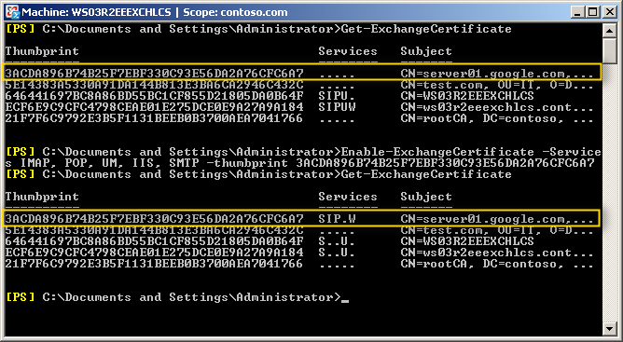

- If the certificate isn't enabled for the correct services (S=SMTP, I=IMAP, P=POP, U=Unified Messaging, W=Web/IIS) you need to run the Enable-ExchangeCertificate command below. You can copy the thumbprint from the output of the Get-ExchangeCertificate command that you just ran.
Enable-ExchangeCertificate -Services IMAP, POP, IIS, SMTP -thumbprint 896B74B25F7EBF330C93E56DA2A76CFC6A7
- After running the Enable-ExchangeCertificate command, run the Get-ExchangeCertificate command again to verify that the certificate is enabled for the correct services.

