- Download and open the file containing your certificate. Your certificate file will be named your_domain_name.cer.
- Copy the your_domain_name.cer file to your Exchange server.
- Start the Exchange Management Console by going to Start > Programs > Microsoft Exchange 2010 > Exchange Management Console.
- Click the link to "Manage Databases", and then go to "Server configuration".
- Select your certificate from the menu in the center of the screen (listed by its Friendly Name), and then click the link in the Actions menu to "Complete Pending Request".
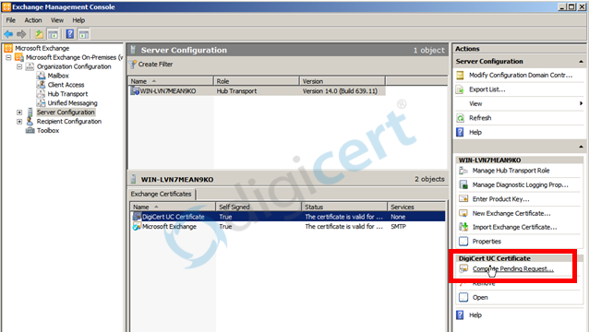
- Browse to your certificate file, then click Open > Complete.
.
- Now, to enable your certificate for use, go back to the Exchange Management Console and click the link to "Assign Services to Certificate."
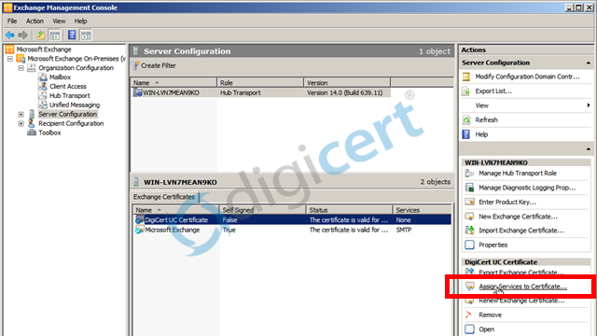
- Select your server from the list provided, then click Next.
- Select the services for which you would like to enable your new certificate, click Next > Assign > Finish.
Your certificate should now be Installed and Enabled for use with Exchange.

