Import the AD FS Certificate to the AD FS Proxy Server
Login to the AD FS Proxy server with an Administrator account
- Open the Start Screen
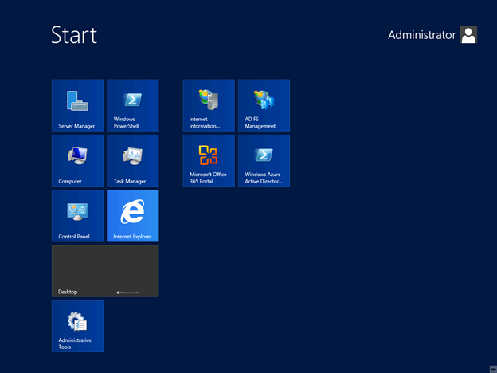
- Type MMC
- Open the MMC
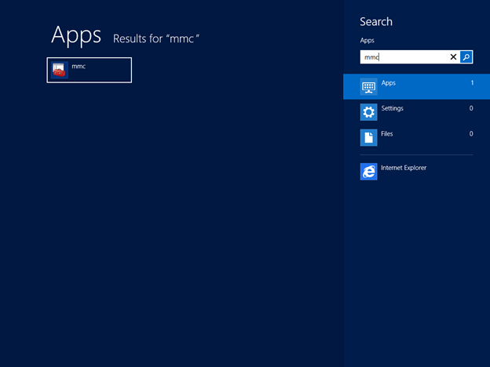
- MMC opens
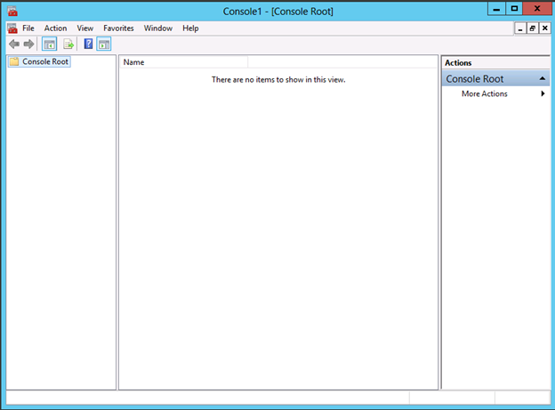
- Click File
- Click Add/Remove Snap-in
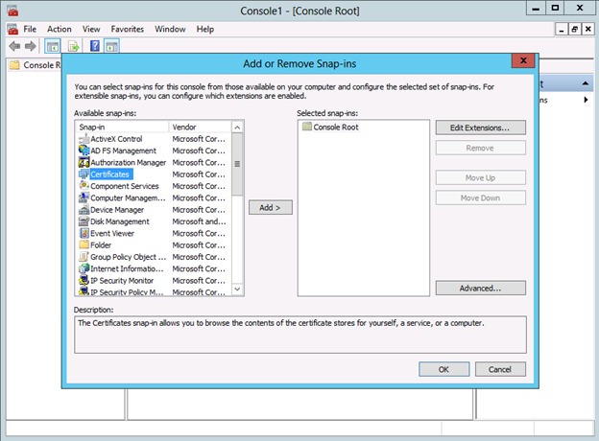
- Select Certificates
- Click Add>
- Select Computer Account
- Click Next
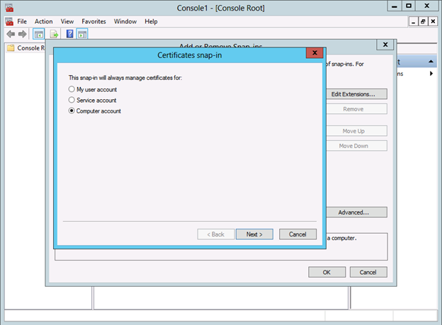
- Select Local Computer
- Click Finish
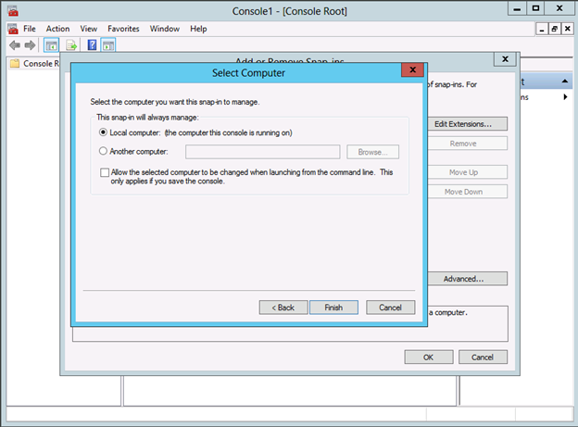
- Click OK
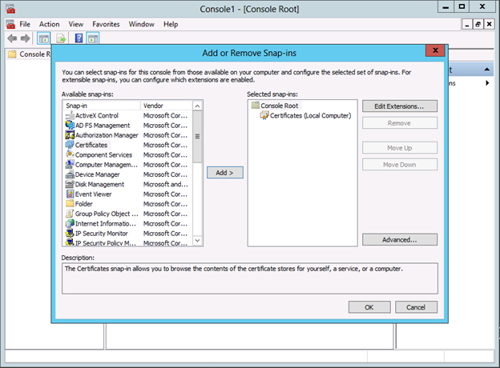
- Expand Certificates
- Expand Personal
- Right Click Certificates
- Select Import

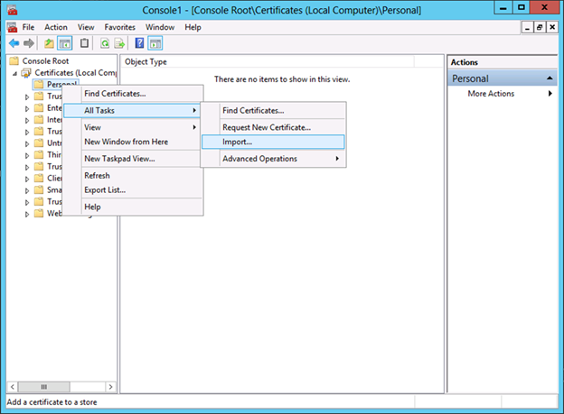
- Select Local Machine
- Click Next
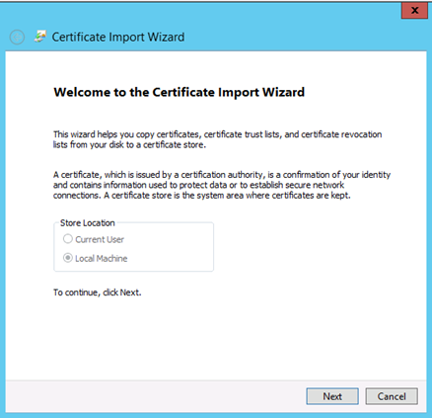
- Browse to the Exported Certificate
- Click Next
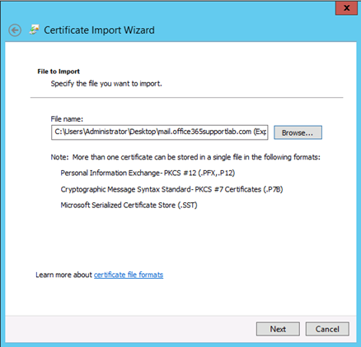
- Enter Password
- Mark the key as exportable
- Click Next
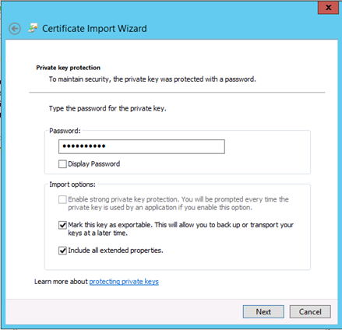

- Place in the Personal certificate store
- Click Next
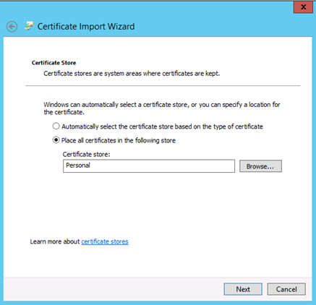
- Click Finish
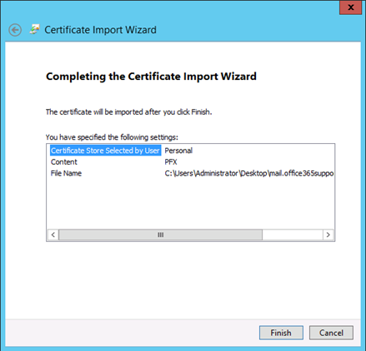
- Successful
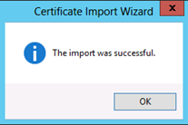
Assign the Imported Certficate
Now that we have the third party certificate imported on the server, we need to assign and bind it to the default website (HTTPS port 443).
- Open Server Manager
- Click Tools
- Click Internet Information Services (IIS) Manager
- Expand the local server
- Expand Sites
- Select Default Web Site
- Click Bindings (actions pane)
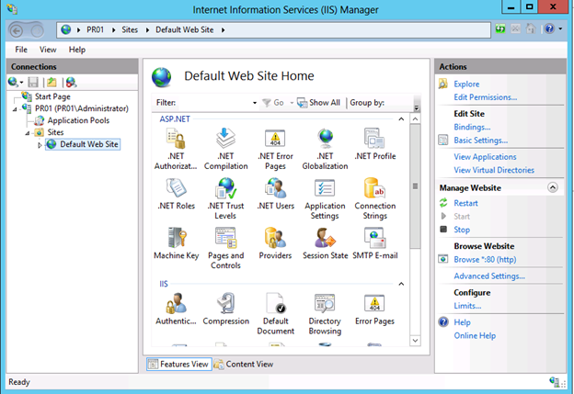
- Click Add
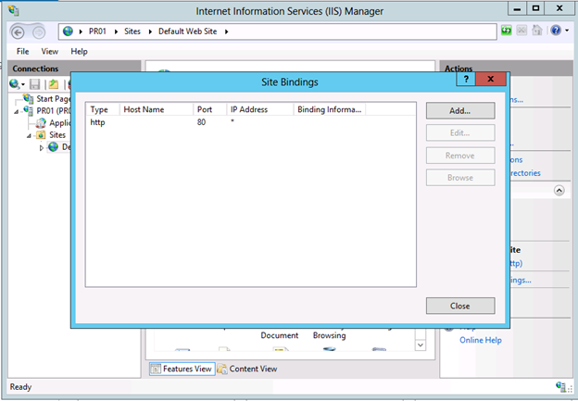
- Change the type to HTTPS
- Select your certificate from the drop down menu.
- Click OK
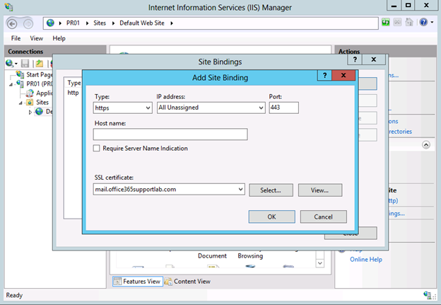
- Click Close
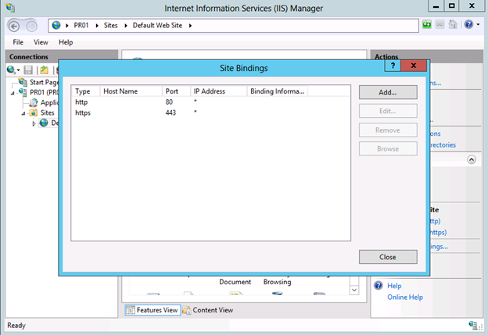
- Close IIS Manager
Now that our certificates are taken care of

