**HOW IS A CSR GENERATED ON JUNIPER SECURE ACCESS VPN?**

To generate the CSR, complete the following steps:

** Note these steps are based on release 6 of the Juniper Secure Access server (version 6.0R6)

1.     In the admin console, choose **System** > **Configuration** > **Certificates** > **Device Certificates**.

2.     Click **New CSR**.

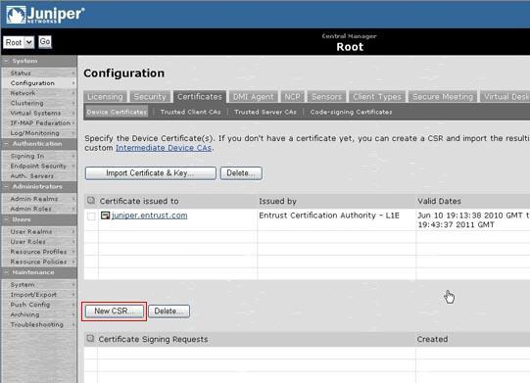

3.     Enter the required information and click **Create CSR**.

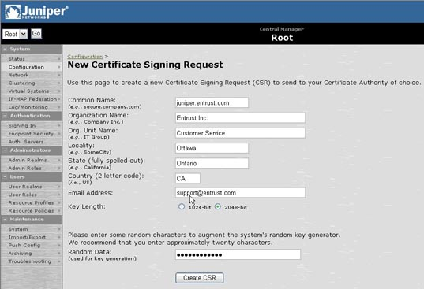

4.     Follow the instructions on-screen under **Step 1. Send CSR to Certificate Authority for signing**, which explains how to save your CSR and submit it to Entrust.

