1.     Copy and paste the Server Certificate (including the BEGIN and END tags) into a text editor such as Notepad and save it on your Local Computer.

2.     In the admin console, choose **System** > **Configuration** > **Certificates** > **Device Certificates**.

3.     Under **Certificate Signing Requests**, click the **Pending CSR** link that corresponds to the signed certificate from Entrust.  
  
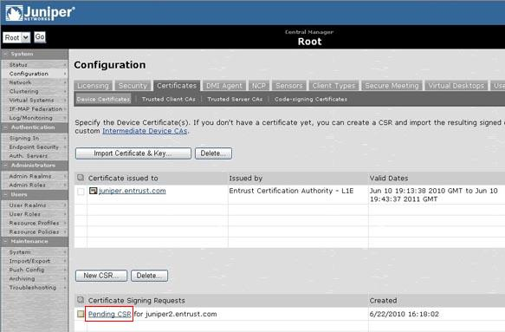

4.     Under **Import signed certificate**, browse to the certificate file and then click **Import**.  
  
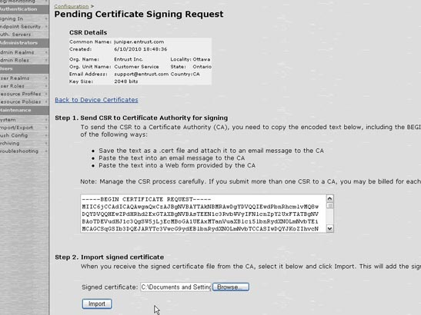

5.     You should see a message confirming that the certificate has been imported successfully. The Server Certificate should appear in the list of Device Certificates.  
  
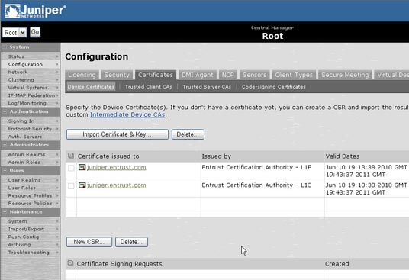

Steps to import the intermediate certificate onto the SSL VPN device:

1.     **Log in**to the admin console

2.     Go to: *System > Configuration > Certificates > Device Certificates*

3.     Click **IntermediateDeviceCAs**.  
  
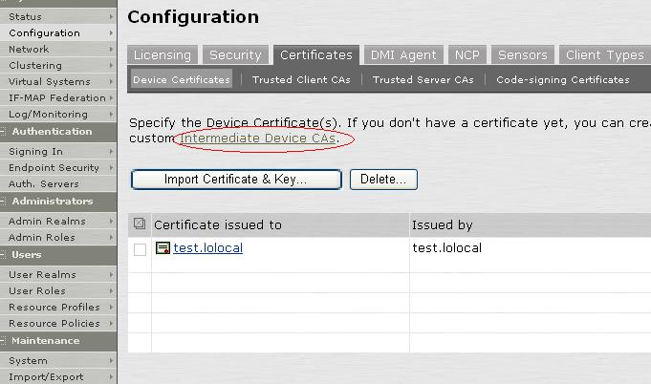

4.     Click **ImportCAcertificate**andimporttheIntermediatecertificate  
  
