- Open Domino Server Certificate Administration (CERTSRV.NSF). This is in the System Databases in the administration panel of Notes.
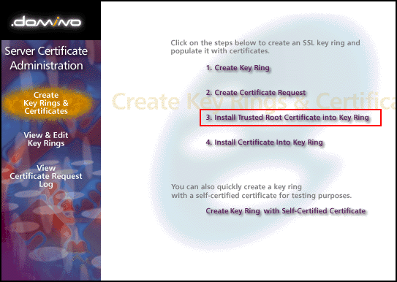
- Choose "Install Trusted Root Certificate into Key Ring". Enter the file name of the key ring that was made when you created your CSR, then install the Trusted Root Certificate (TrustedRoot.crt). You may get a message that the root certificate is already installed as a trusted root. If you receive this message continue to step 3.
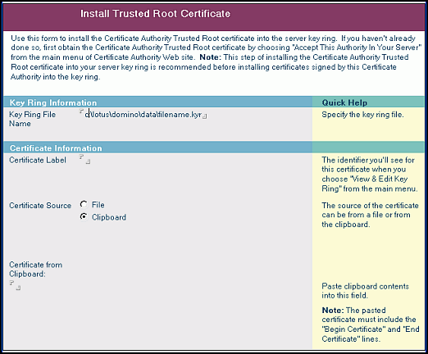
- Again choose "Install Trusted Root Certificate into Key Ring". Enter the file name of the key ring, then install your Intermediate Certificate(s). If your zip file includes DigiCertCA2.crt, install that file first, and then install repeat this process and install DigiCertCA.crt next to this same location. Otherwise, you only need to install the DigiCertCA.crt file here.
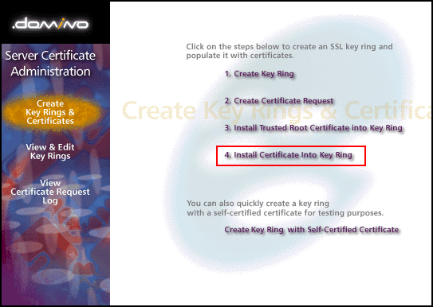
- This time choose "Install Certificate into Key Ring". Enter the file name of the Key Ring, then install your Primary Certificate (your_domain_name.crt) using the "Merge Certificate into Key Ring" button.
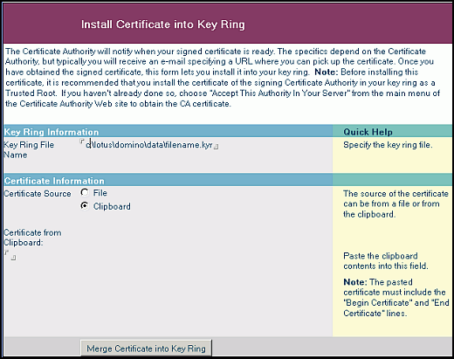
Your SSL Certificate now installed to your Key Ring and it is ready for use on your Lotus Domino Server.

