**Installation server certificate on Edge Server with Microsoft Lync 2010 Server**

1.   Start > All Programs > Microsoft Lync Server 2010 > Lync Server Deployment Wizard  
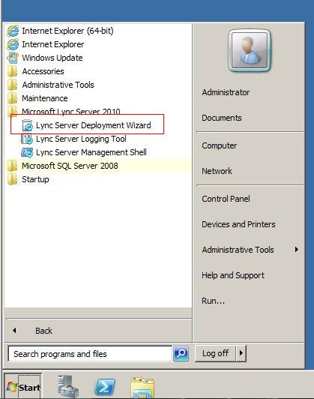

2.   Select Install or Update Lync Server System  
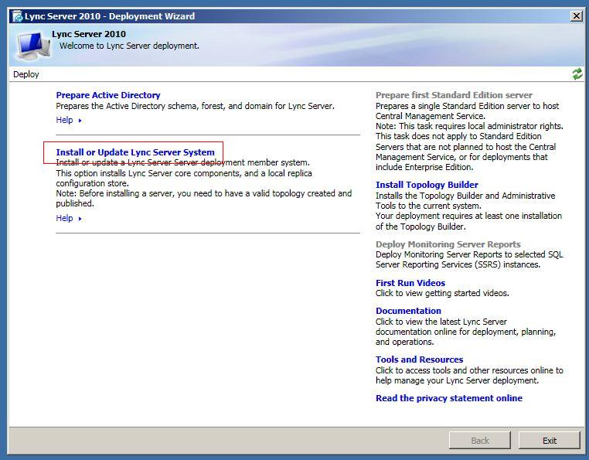

3.   Click Run button on step 3 Request, Install or Assign Certificates  
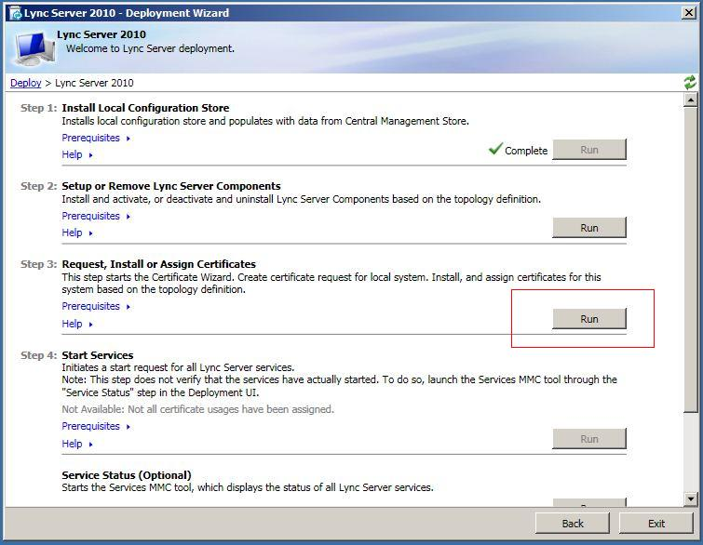

4.   Select External Edge Certificate and click Import Certificate button  
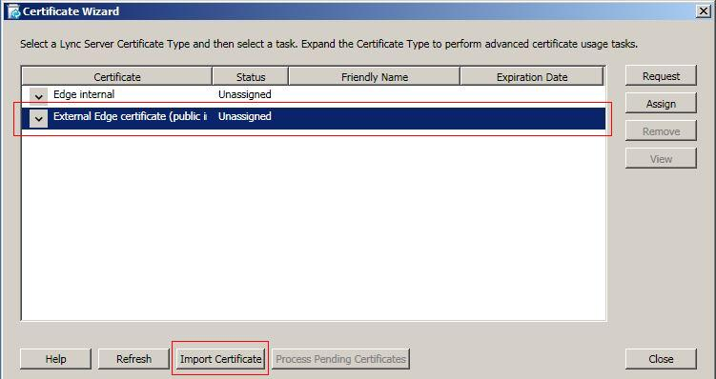

5.   On Import Certificate window, type in or browse the location of the certificate file. The default name of the certificate file is entrustcert.crt. click next button to continue.  
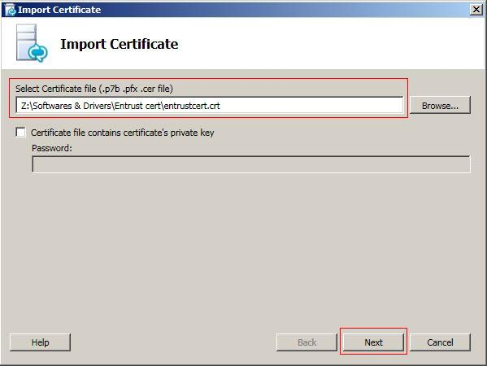

6.   Click next button to continue on Import Certificate Summary.  
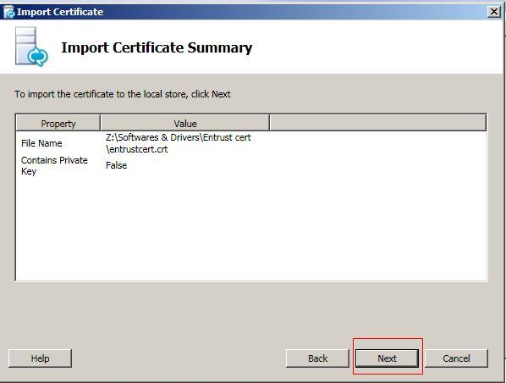

7.   On Executing commands window, make sure the task status is completed and click Finish button.  
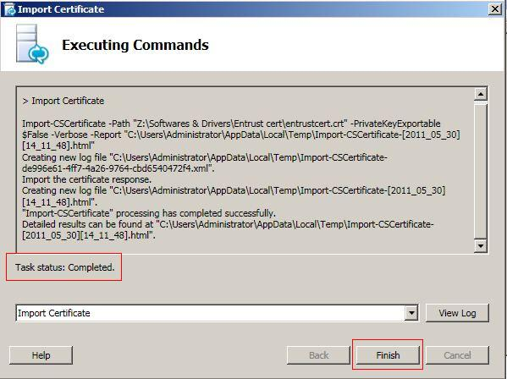

8.   On certification wizard, select External Edge Certificate and click Assign button  
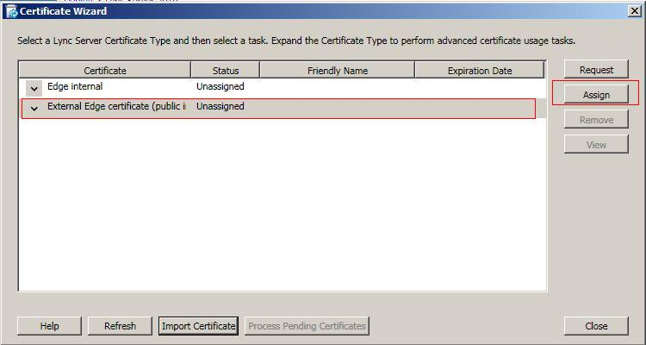

9.   Click Next on the Certificate Assignment window to continue.  
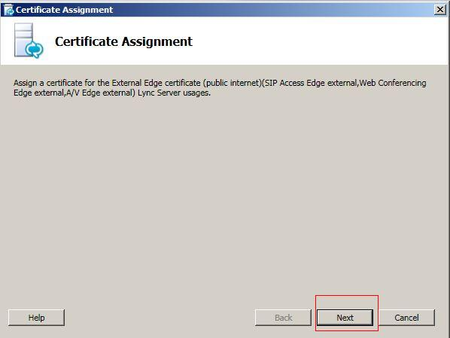

10. On Certificate Store window, click the View Certificate Details button to view the server cert if needed,  otherwise click next button to continue.  
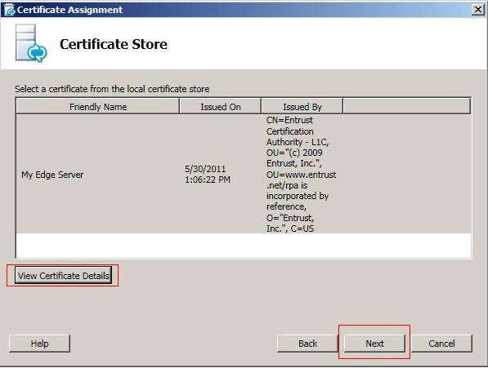

11.      Wait until task status show completed and click Finish button  
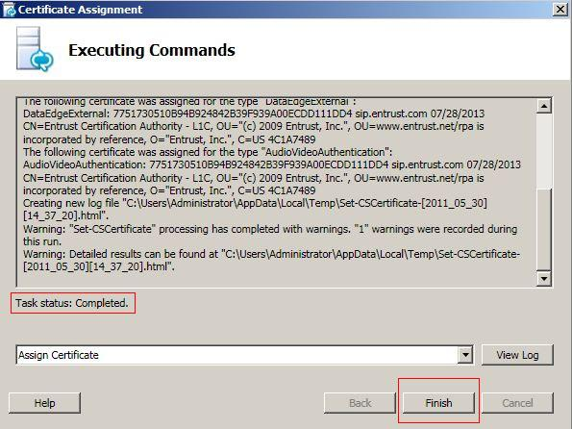

12.      Your server cert has been installed and assigned.  
