**Generating a CSR with Plesk Panel**

**Logon to the Plesk Panel**

•         Go to **Domains > Domain name > SSL Certificates**. A list of SSL certificates that you have in your repository will be displayed.

•         Click **Add SSL Certificate.**

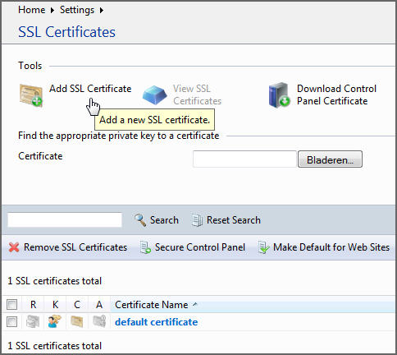

•         Specify the Certificate **properties**:

•         Enter a Certificate name, this will help you identify this certificate in the repository.

•         Enter the requested information:  
Bits = encryption level. Choose the encryption level of your SSL certificate. We recommend a value equal or more than 2048 bit.  
Country, State/Province, Location = official address of your company or organisation  
Organisation = the name of your company or organisation  
Organisation department = optional field for the name of the responsible department or division  
Domain name (Common Name) = the domain name for which the SSL certificate will be used, like [mail.youdomain.com](http://mail.youdomain.com)

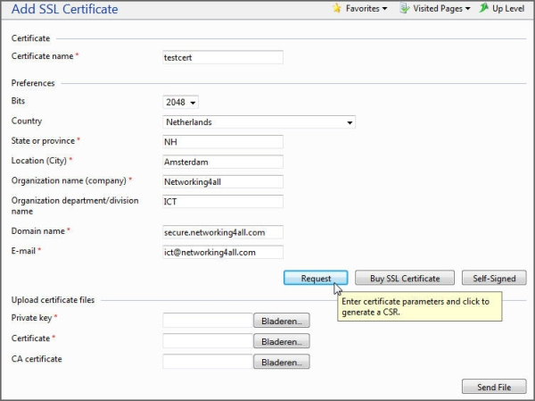

Make sure that all the provided information is correct and accurate, as it will be used to generate your private key.

•          Click **Request.** Your private key and certificate signing request will be generated and stored in the repository.

•         In the list of certificates, click the name of the certificate you need. A page showing the certificate properties opens.

•         Locate the CSR section on the page, and copy the text that starts with the line -----BEGIN CERTIFICATE REQUEST----- and ends with the line -----END CERTIFICATE REQUEST----- to the clipboard. (see example below)

-----BEGIN CERTIFICATE REQUEST-----

MIIBxzCCATACAQAwgYYxCzAJBgNVBAYTAlVTMQswCQYDVQQIEwJWQTEQMA4GA1UE

BxMHSGVybmRvbjESMBAGA1UEChMJUGFyYWxsZWxzMRswGQYDVQQDExJkZW1vLnBh

cmFsbGVscy5jb20xJzAlBgkqhkiG9w0BCQEWGHNhbGVzQGRlbW8ucGFyYWxsZWxz

LmNvbTCBnzANBgkqhkiG9w0BAQEFAAOBjQAwgYkCgYEAz2XpSkAi0Tc3S+LBDhh7

lc2em4zir2T0Mnk4TaBvMB0qFxtarlew52Ij4Oi8o/M5jSaKJJE5TL9waB3keJBc

kGg2T7U/EErueOmwAHKjD6ocQ4p0+ceevZKFfQ/e/CVNpun9NKvOsQ+gD8GlLiUF

CFHj/YanUSTPBBYcfzigUkMCAwEAAaAAMA0GCSqGSIb3DQEBBQUAA4GBAGfdNA2a

JH7G6WFc9JnFgGwpd6zf8ROyADnabGtha0afyzffi9i8mXSAhUwdhJq2f3KzYyJn

LtoMJh5dAXCAxwAYeVkqKY9h4J01tI6X+qskdWy1Q5sRR/ghvT3DMvgM4vWNbfub

GFBzQb/8SBLvu1Mo66E1LPJdetuPqdeDzgvU

-----END CERTIFICATE REQUEST-----