Installation of your certificate with Plesk Panel
When you receive your SSL certificate by e-mail, save it on your local machine or network.
Follow the steps below to install your certificate:
- Logon to the Plesk Panel and go to the SSL Certificates repository (Domains > Domain name > SSL Certificates).
- Select the appropriate Certificate name from the repository list.
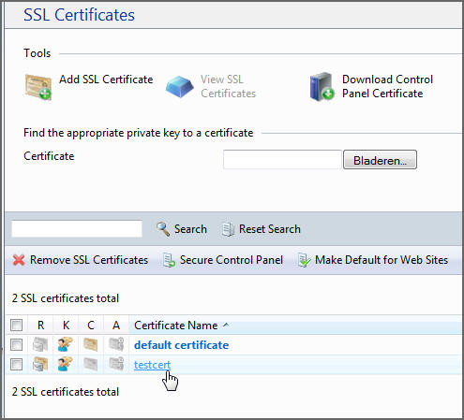
- Click Browse in the middle of the page and navigate to the location of the saved certificate.
Select it, and then click Send File.
You also have the option to copy and paste the contents of your certificate in the text box below.
This will upload and install the certificate against the corresponding private key.
- Return to the domain's administration screen (Domains > Domain name) and click Web Hosting Settings.
- Select the SSL certificate that you wish to install from the Certificate menu.
If there is no Certificate menu on the screen, this means that you are on a shared hosting account; therefore, you need to upgrade your hosting package and purchase a dedicated IP address from your provider.
- Select the SSL support check box and click OK.

