**SAP-PI SERVER**

1.  Open NetWeaver Administrator (http://<FQDN>:5<XX>00/nwa)

[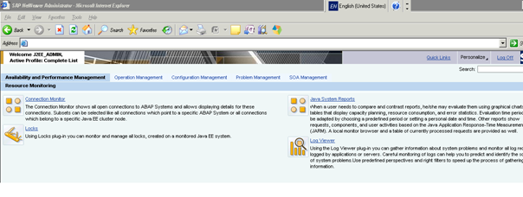](http://scn.sap.com/servlet/JiveServlet/showImage/102-26145-1-89242/pastedImage_32.png)

2. Go to **Configuration Management --> Certificates and Keys**

[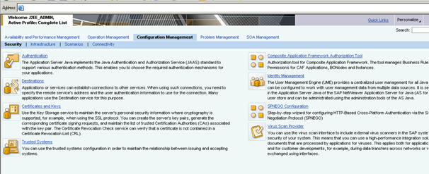](http://scn.sap.com/servlet/JiveServlet/showImage/102-26145-1-89270/pastedImage_34.png)

3. Select **ICM_SSL_<ID>** and you will find the default **Private key** and **Certificate** when SSL has not yet been configured.

[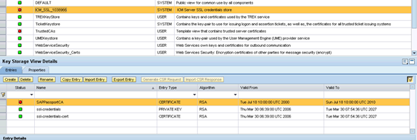](http://scn.sap.com/servlet/JiveServlet/showImage/102-26145-1-89271/pastedImage_38.png)

4. Rename or delete the old/obsolete certificates.

[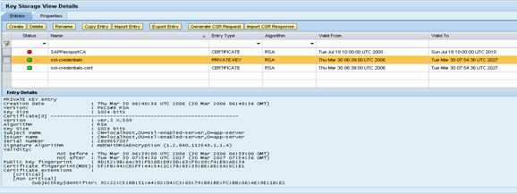](http://scn.sap.com/servlet/JiveServlet/showImage/102-26145-1-89272/pastedImage_42.png)

Description: http://scn.sap.com/docs/DOC-26145

[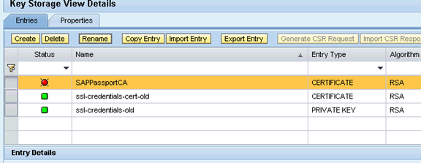](http://scn.sap.com/servlet/JiveServlet/showImage/102-26145-1-89274/pastedImage_45.png)

5. Create new Private Key (**ssl-credentials**) as shown in the below screenshots.

[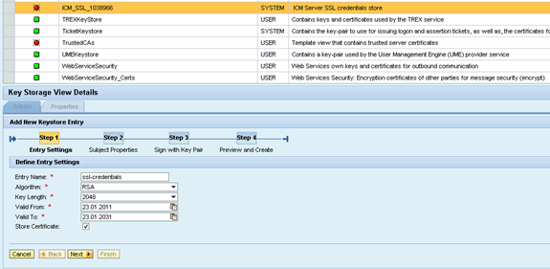](http://scn.sap.com/servlet/JiveServlet/showImage/89289/pastedImage_3.png)     Description: http://scn.sap.com/docs/DOC-26145

     Note: Certificate (**ssl-credentials-cert**) will be generated automatically when we choose ‘Store Certificate’ in the above screenshot.

[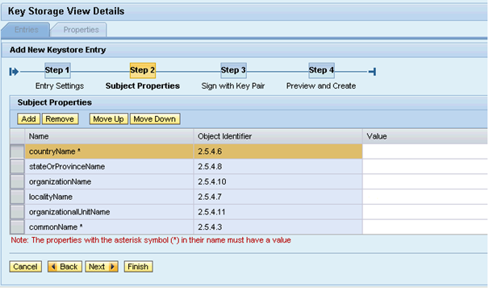](http://scn.sap.com/servlet/JiveServlet/showImage/89290/pastedImage_5.png)     Description: http://scn.sap.com/docs/DOC-26145

     Country Name and Common Name (CN) are mandatory fields.

     Just click NEXT

[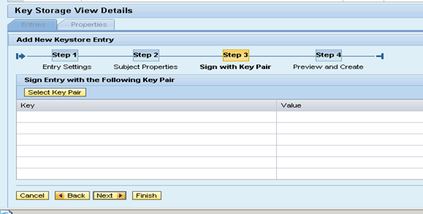](http://scn.sap.com/servlet/JiveServlet/showImage/102-26145-1-89277/pastedImage_61.png)

     Click Finish

[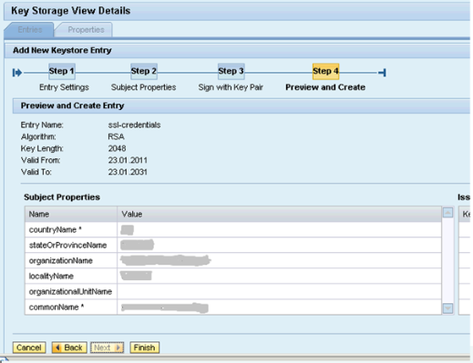](http://scn.sap.com/servlet/JiveServlet/showImage/102-26145-1-89278/pastedImage_66.png)

6. Now you should be able to see Subject name and Issuer name as **CN=<Fully qualified name>, L= <Locality Name>, O=<Organization Name>,           ST=<State or Province>, C=<Country Name>**.

7. Select **ssl-credentials** and click on ‘**Generate CSR Response**’

[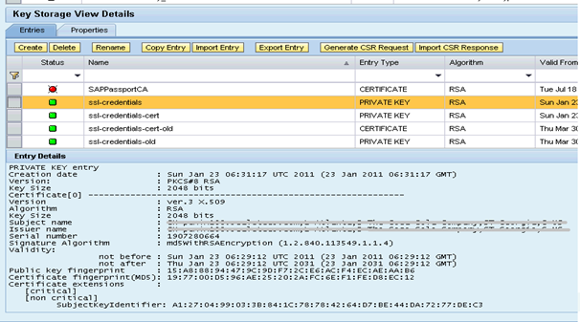](http://scn.sap.com/servlet/JiveServlet/showImage/89291/pastedImage_7.png)     Description: http://scn.sap.com/docs/DOC-26145

8. Click **Download** and save the CSR certificate in text format with .csr extension and send it to [Certificate](mailto:SSLCertificates@na.ko.com) Authorityfor entrust certificates.

[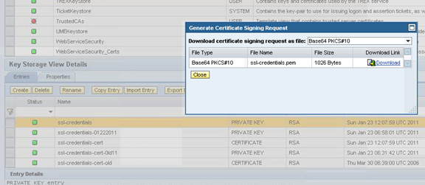](http://scn.sap.com/servlet/JiveServlet/showImage/102-26145-1-89280/pastedImage_76.png)

[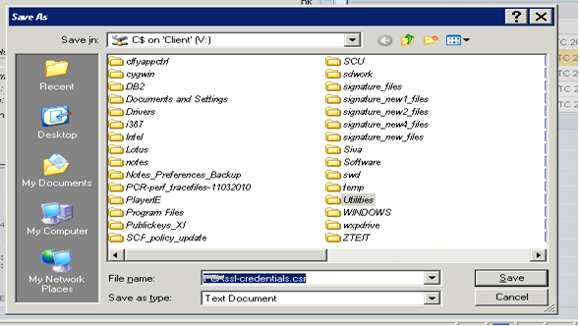](http://scn.sap.com/servlet/JiveServlet/showImage/89293/pastedImage_10.png)