Go to NWA-->Configuration Management --> Certificates and Keys and select **ICM_SSL_<ID>.**

Click on ‘**Import CSR response**’

[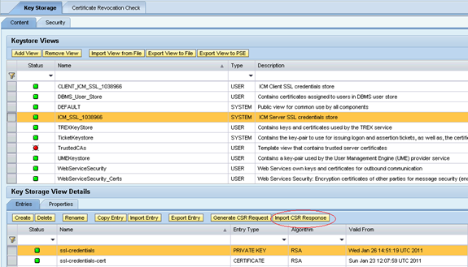](http://scn.sap.com/servlet/JiveServlet/showImage/102-26145-1-89283/pastedImage_91.png)

     Note: We will get 3 certificates from CA, **Web Server, Entrust cross** and **Entrust root**. Import them in the same order.

     Once all 3 certificates are added, and then only click on ‘**Import**’ button.

[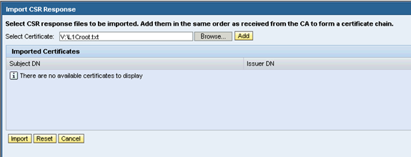](http://scn.sap.com/servlet/JiveServlet/showImage/89294/pastedImage_12.png)

[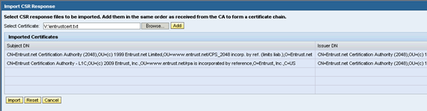](http://scn.sap.com/servlet/JiveServlet/showImage/89296/pastedImage_14.png)

Description: http://scn.sap.com/docs/DOC-26145

Description: http://scn.sap.com/docs/DOC-26145

2. Now you should be able to see chain certificates Certificate[0], Certificate[1] and Certificate[2] and Issuer name as ‘**Entrust Certification Authority**’.

[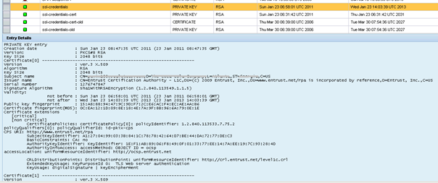](http://scn.sap.com/servlet/JiveServlet/showImage/89319/pastedImage_4.png)     Description: http://scn.sap.com/docs/DOC-26145

[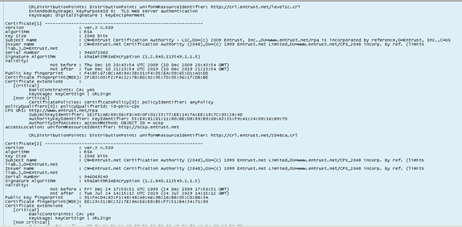](http://scn.sap.com/servlet/JiveServlet/showImage/89311/pastedImage_7.png)

3. We should do Export View to PSE after steps 1 and 2 are completed successfully.

Description: http://scn.sap.com/docs/DOC-26145

     You should be able to see successful message at the top left screen.

[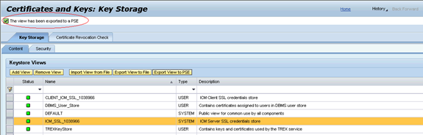](http://scn.sap.com/servlet/JiveServlet/showImage/89303/pastedImage_16.png)

4. Restart **SSL Provider** service.

Description: http://scn.sap.com/docs/DOC-26145

[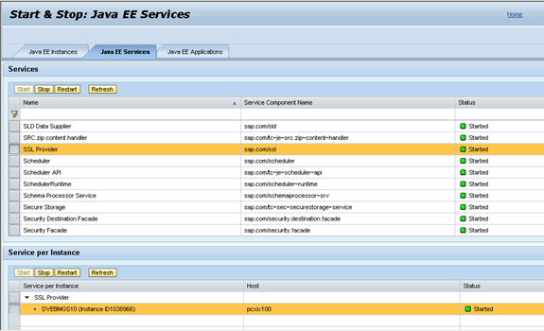](http://scn.sap.com/servlet/JiveServlet/showImage/89314/pastedImage_13.png)

5. Restart ICM from transaction SMICM.

[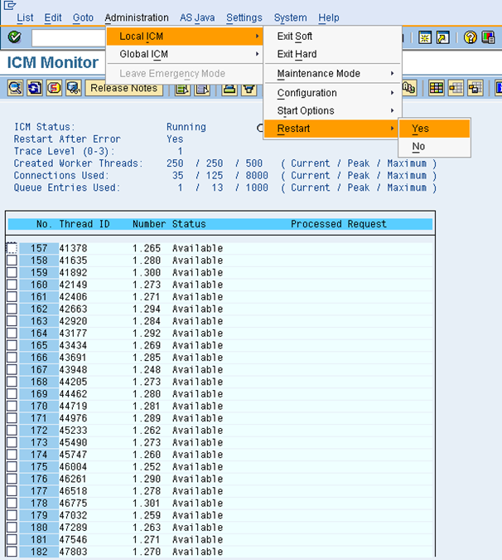](http://scn.sap.com/servlet/JiveServlet/showImage/89322/pastedImage_11.png)

6. Double click on lock symbol at the bottom of the browser and now you should be able to see **Issued by: <Certificate Authority>.**

[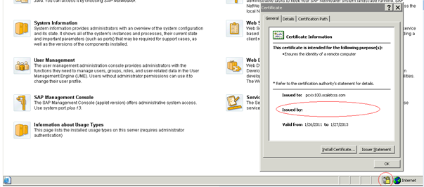](http://scn.sap.com/servlet/JiveServlet/showImage/89316/pastedImage_20.png)

**III. Setup HTTPS auto redirect, if necessary.**

1. Open**NWA-->Configuration Management**-->**Infrastructure**-->**Java System Properties**

[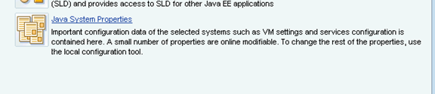](http://scn.sap.com/servlet/JiveServlet/showImage/89326/pastedImage_0.png)Description: http://scn.sap.com/docs/DOC-26145

2. Select **HTTP Provider** service and update **Proxy Mappings** field.

[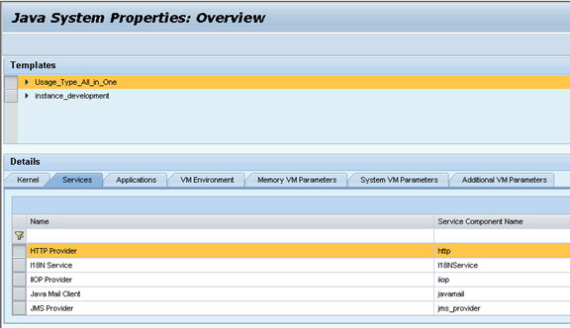](http://scn.sap.com/servlet/JiveServlet/showImage/89327/pastedImage_1.png)Description: http://scn.sap.com/docs/DOC-26145

**ProxyMappings 5<XX>00=(Host:<FQDN>,Port:84<XX>,Scheme:https,Override:true)**

[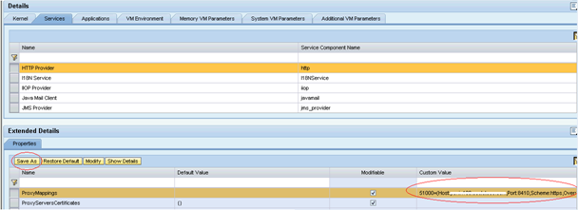](http://scn.sap.com/servlet/JiveServlet/showImage/89328/pastedImage_2.png)Description: http://scn.sap.com/docs/DOC-26145

3. Click **SAVE AS** to save the settings.