Generating a Certificate Signing Request (CSR) on WHM

To generate your CSR, you will need to log in to your WHM account.  WHM (the administrator panel) have slightly different ways to request certificates and generate CSRs.

**WHM**

1.    Log in to WHM. From the menu, navigate to the 'SSL/TLS' section, and click 'Generate a SSL Certificate and Signing Request'.

[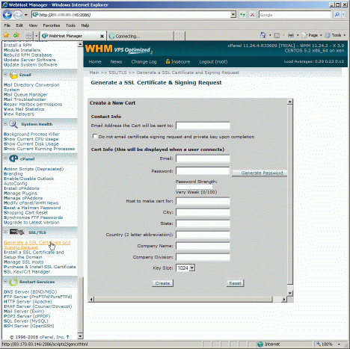](http://customer.globessl.com/images/WHM_1.gif)

2.    Fill out the form. 'Host to make cert for' is where you should enter the name of the site you want the certificate for.   
  
We advise to use at least a 2048-bit key, Click 'Create'.

[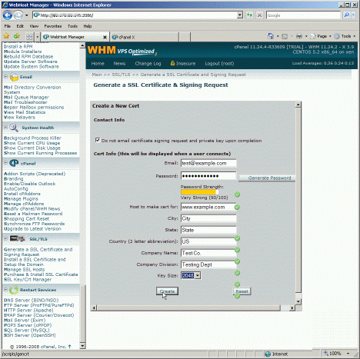](http://customer.globessl.com/images/WHM_2.gif)

3.    Finally you will be presented with the CSR (labelled 'Signing Request'), the private key and a temporary self-signed certificate.   
Copy and paste the contents of the CSR into the enrollment form when requested.

[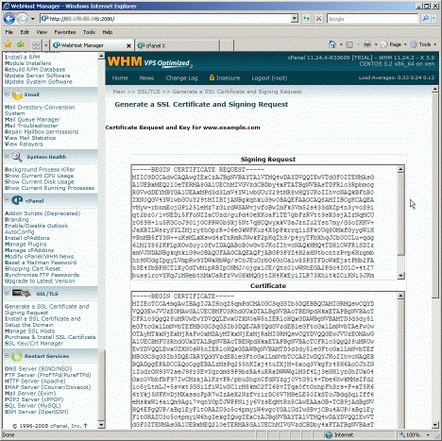](http://customer.globessl.com/images/WHM_3.gif)