- Login to your WebHost Manager (WHM) control panel.
- On the left menu, click on Install a SSL Certificate and Setup the Domain.
- In the first box, you will need to paste the contents of your Primary Certificate (yourdomain.crt). To access the text version of your certificate, open it with a text editor. When copying and pasting your certificate, include the BEGIN and END tags.
- Fill in the required Domain / User / IP address information. The domain and IP address may fill in automatically. Type your WHM username in the User field.
- In the middle box you will need paste the correct RSA private key that was generated with the CSR. This private key was sent to your email address when you generated your CSR. The private key may fill in automatically if the server recognizes your Certificate or if you click the Fetch button.
- In the bottom box you will need to paste the contents of the Intermediate Certificate (CA.crt).
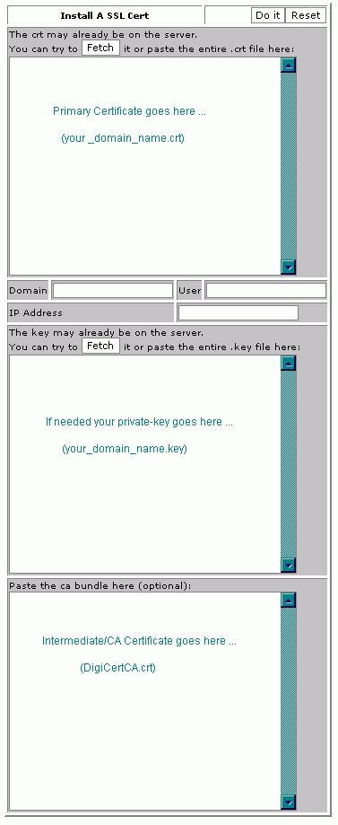
- Press the Do it button. Your SSL Certificate should now be installed, and the website configured to accept secure connections. You or your web host may need to restart Apache before it will work.

